**User Manual**

Register for an account on the top right of the page or else access is restricted to the majority of the site.

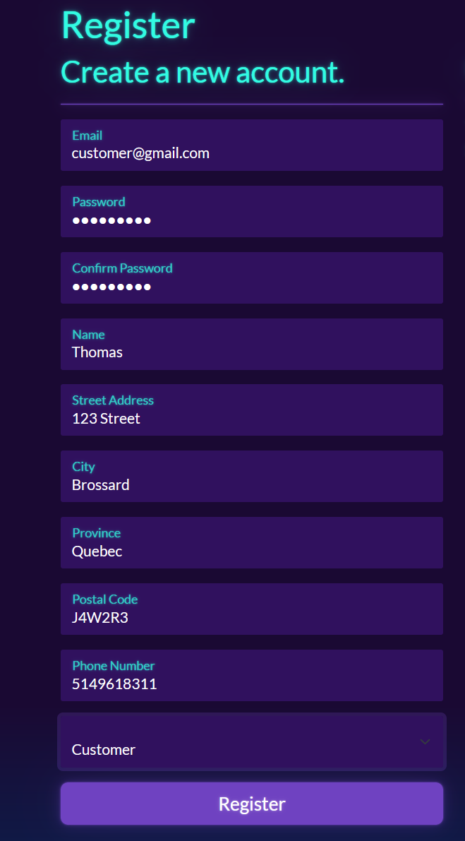

Register for an account. For the purposes of demonstration, a person is able to select their role for site wide access. This feature is normally reserved for administrators. Now that an account is registered, you are returned to the index page. To add items to the shopping cart, click on any of the “Bulk Pricing available!” buttons.

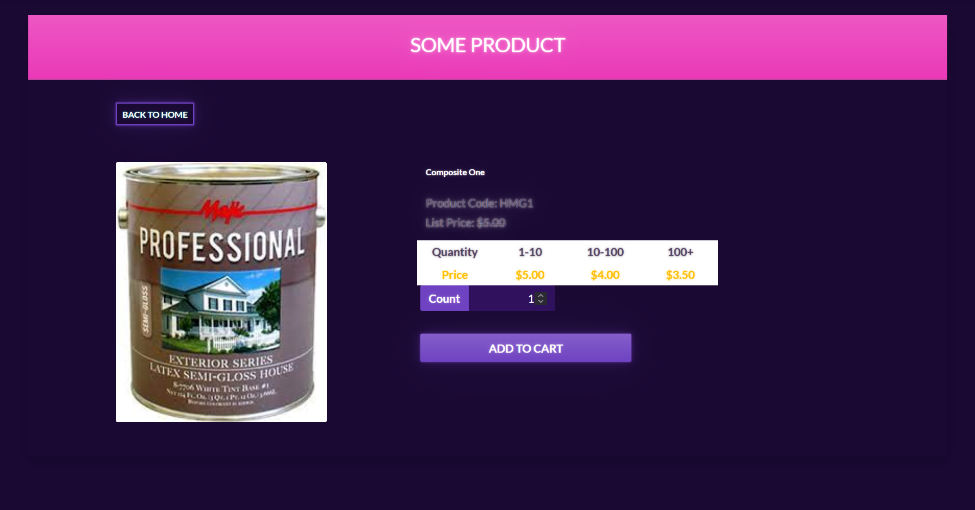 Select a quantity and click “Add to Cart”. You are then returned to the index to select more products. Click the Shopping Cart on the navbar.

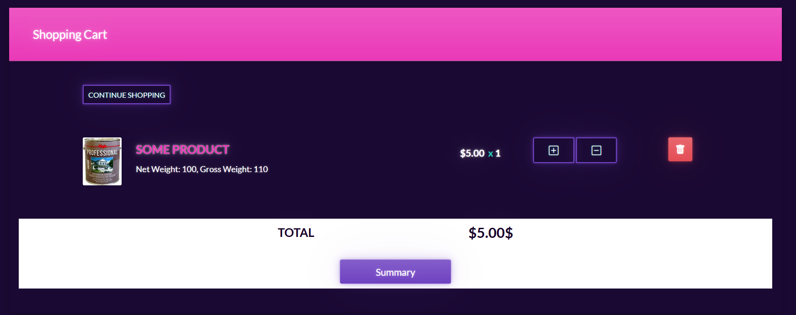 You can now adjust the quantity purchased or go directly to Summary.

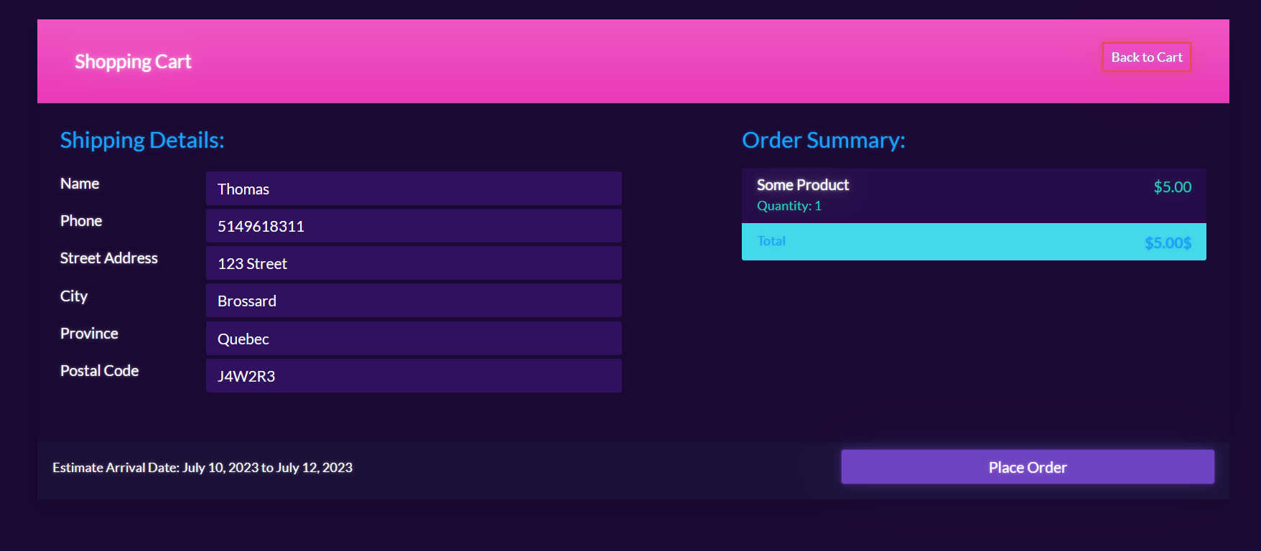 The summary puts your account’s details as the shipping information. You can edit these before placing an order and change the address or recipient if you desire. Place the order.

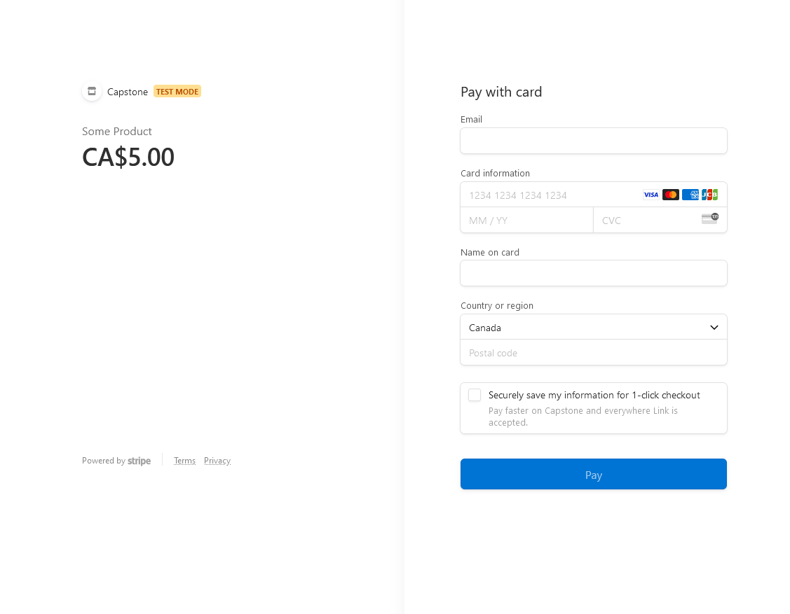 You are now redirected to a Stripe page for confirmation of payment. If payment is successful, you were be redirected to the following page.

